PENETRATION TESTING REPORT

FOOTPRINTING & NETWORK SCANNING PHASES

Pentester / Intern
Srushti Shewale

Program
Cybersecurity Internship – Networkwalks

Week
Week 02

Date
10 November 2026

Modules Completed
W2-PM1 – Footprinting with Multiple Kali Tools
W2-PM5 – Zenmap Network Scanning

Target / Scope
Networkwalks.com – Footprinting & Reconnaissance
My Own Local LAN – Network Scanning

Phases Covered
Phase 1: Reconnaissance & Footprinting
Phase 2: Scanning & Network Discovery

1. Liability Disclaimer
These materials are prepared for educational and research purposes as part of the Cybersecurity Internship program at Networkwalks. The practical activities documented in this report were performed within the assigned learning scope and on systems or networks permitted for the exercise.
The purpose of these activities is to understand cybersecurity concepts such as reconnaissance, footprinting, DNS enumeration and network discovery, and to learn how such techniques can be used to identify and defend systems against potential security threats.
Do not use the techniques, commands or information contained in this report to access, scan or test systems without proper authorization. Unauthorized access or scanning may be illegal and may result in criminal charges, financial penalties, employment consequences or other legal action.
Security testing should only be performed when:
- You are testing a device or network that you own or a designated laboratory environment.
- You have appropriate written and documented permission from the owner.
- You are working under an authorized security assessment with a clearly defined scope.
The author, instructor and Networkwalks are not responsible for any misuse of the information contained in this report. All actions performed using this knowledge are the responsibility of the individual performing them.
The findings documented in this report represent observations from the assigned footprinting and network scanning exercises. They should not be interpreted as confirmed security vulnerabilities unless explicitly validated through authorized security testing.

2. Introduction
This report documents the Week 2 cybersecurity practical activities completed as part of the Networkwalks Cybersecurity Internship. The activities covered two main areas: footprinting and reconnaissance using multiple Kali Linux tools (W2-PM1), and network scanning and discovery using Zenmap (W2-PM5).
For W2-PM1, reconnaissance was performed against the networkwalks.com domain using six Kali Linux tools: WHOIS, WhatWeb, Nslookup, Curl, Wafw00f and DNSRecon. Each tool was used to collect a different type of publicly observable information, including domain registration details, web technologies, IP address information, HTTP response headers, Web Application Firewall identification and DNS records.
For W2-PM5, Zenmap was used to perform network discovery on the user's own local LAN. The activity included identifying the local IP address and subnet using Windows ipconfig, performing a Ping Scan, identifying live hosts and examining host and network topology information.
The purpose of these exercises was to understand how information can be gathered during the reconnaissance phase and how network discovery can be used to identify active devices. The activities also demonstrated the importance of documenting observations and performing security testing only within an authorized scope.

3. Tools Used
The following tools and utilities were used during the Week 2 footprinting and network scanning activities.
Tool | Purpose
Kali Linux | Operating system used for the footprinting and reconnaissance activities.
WHOIS | Used to obtain publicly available domain registration information, registrar details and name server information.
WhatWeb | Used to identify web technologies, server information, CMS and other technologies exposed by the website.
Nslookup | Used to resolve the domain name to its corresponding IP address using DNS.
Curl | Used with the -I option to inspect the HTTP response headers of the website.
Wafw00f | Used to identify whether a Web Application Firewall protects the website.
DNSRecon | Used to enumerate DNS information including NS, MX, A, TXT and SRV records.
Windows CMD | Used to identify the local IP address, subnet mask and default gateway using ipconfig.
Zenmap (Nmap GUI) | Used to perform a Ping Scan, identify live hosts and examine network topology information.
Windows Snipping Tool / Screenshot | Used to capture visual evidence of the practical activities and scan results.

4. Activities Performed

4.1 Footprinting & Reconnaissance
Footprinting and reconnaissance were performed against the networkwalks.com domain using six Kali Linux tools: WHOIS, WhatWeb, Nslookup, Curl, Wafw00f and DNSRecon.
Each tool was used for a specific reconnaissance purpose, such as collecting domain registration information, identifying web technologies, resolving the domain to an IP address, examining HTTP response headers, detecting the presence of a Web Application Firewall and enumerating DNS records.
The following sections document the command used, the observations obtained and the security significance of each activity.

4.1.1 WHOIS
Command Used:
whois networkwalks.com
Purpose:
WHOIS was used to obtain publicly available registration and administrative information associated with the networkwalks.com domain.
Observed Results:
The WHOIS query provided the following information:
- Domain: NETWORKWALKS.COM
- Registrar: GoDaddy.com, LLC
- WHOIS Server: whois.godaddy.com
- Creation Date: 6 November 2019
- Registry Expiry Date: 6 November 2027
- Name Servers: NS6135.HOSTGATOR.COM and NS6136.HOSTGATOR.COM
- Registrant information: Privacy-protected through Registration Private / Domains By Proxy, LLC
- DNSSEC: Unsigned
Security Significance:
The WHOIS query demonstrated how publicly available domain registration information can provide useful information during the reconnaissance phase. Details such as the registrar, registration dates and name servers can help a security professional understand aspects of the domain's registration and DNS infrastructure.
The information collected is an observation from passive reconnaissance and does not by itself indicate a security vulnerability.
Evidence:
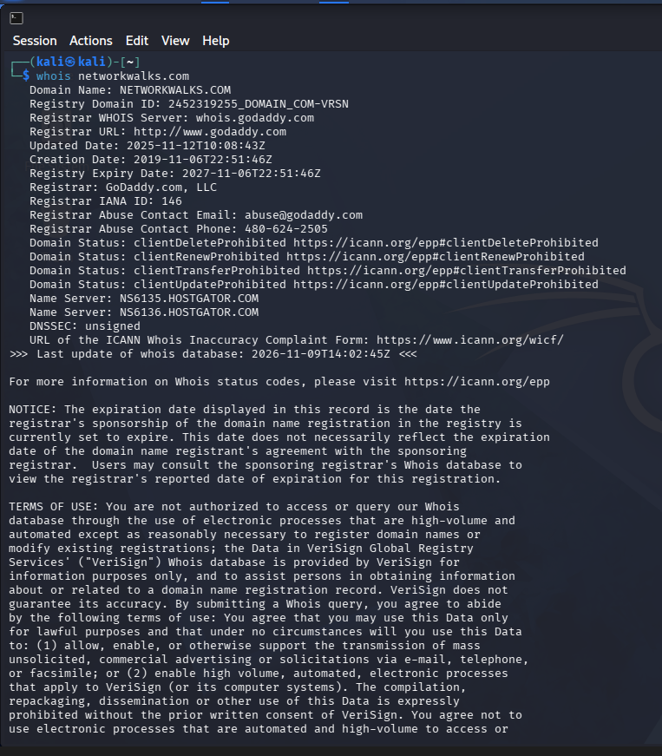
Figure 1: WHOIS information for networkwalks.com

4.1.2 WhatWeb
Command Used:
whatweb networkwalks.com
Purpose:
WhatWeb was used to identify the technologies and web components exposed by the networkwalks.com website.
Observed Results:
The WhatWeb scan identified the following information:
- Web server: Apache
- IP address: 192.232.216.135
- CMS: WordPress
- WordPress version identified: 7.1.4
- WordPress Download Manager: 3.3.76
- jQuery: 3.7.1
- Bootstrap: 7.1.4
- Google Tag Manager: Identified
- HTTP status: 200 OK for HTTPS
- Email address exposed: info@networkwalks.com
- Cookie: __wpdm_client
- Page title: Networkwalks Academy
The HTTP version of the site also returned a 301 Moved Permanently redirect to the HTTPS version.
Security Significance:
WhatWeb demonstrated how web technology fingerprinting can reveal information about the technologies and components used by a website. Information such as the web server, CMS, software versions, IP address and publicly exposed email address can help a security professional understand the technology stack during reconnaissance.
The identified software versions are observations from the WhatWeb scan and were not independently tested for vulnerabilities during this exercise.

Evidence:
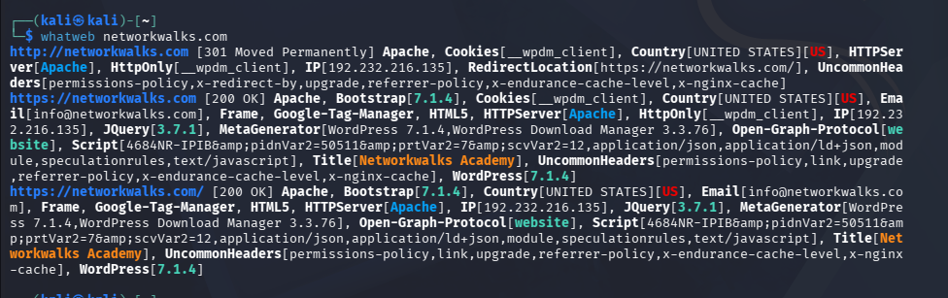
Figure 2: WhatWeb technology fingerprinting results for networkwalks.com

4.1.3 Nslookup
Command Used:
nslookup networkwalks.com
Purpose:
Nslookup was used to determine the IP address associated with the target domain and identify the DNS server used for the query.
Observed Results:
- DNS server used: 8.8.8.8
- Target domain: networkwalks.com
- Resolved IPv4 address: 192.232.216.135
- The response was identified as a Non-authoritative answer.
Security Significance:
DNS lookup provides the IP address associated with a domain. This information can be useful during reconnaissance because attackers may use the resolved IP address as a starting point for further authorized network and service enumeration.
The result itself is an observation from the reconnaissance exercise and does not indicate a confirmed vulnerability.
Evidence:
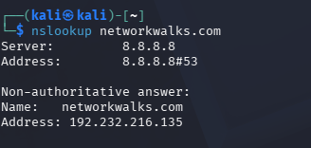
Figure 3: Nslookup result for networkwalks.com

4.1.4 Curl
Command Used:
curl -I https://networkwalks.com
Purpose:
Curl was used to inspect the HTTP response headers returned by the target website. This helps identify information such as the web server, cookies, security-related headers, caching behavior, and other HTTP response details.
Observed Results:
- HTTP response: HTTP/2 200
- Server: Apache
- Content type: text/html; charset=UTF-8
- A WordPress REST API endpoint was exposed through the Link header.
- A WordPress cookie named __wpdm_client was identified.
- The cookie was marked as Secure and HttpOnly.
- X-Nginx-Cache: WordPress was present.
- X-Endurance-Cache-Level: 0 was present.
- Referrer-Policy: no-referrer-when-downgrade was present.
- The response also contained a WordPress shortlink.
Security Significance:
HTTP response headers can provide useful information about the target's web server, application behavior, cookies, and configuration. Such information can assist in reconnaissance and help identify areas for further authorized security assessment.
The observed headers do not by themselves confirm a vulnerability. No exploitation or vulnerability validation was performed during this activity.

Evidence:
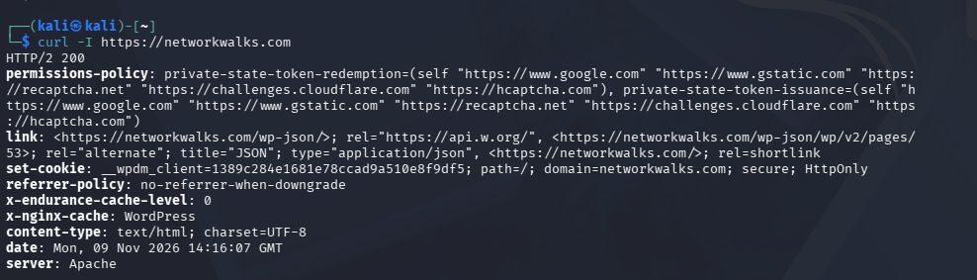
Figure 4: Curl HTTP header response for networkwalks.com

4.1.5 Wafw00f
Command Used:
wafw00f networkwalks.com
Purpose:
Wafw00f was used to identify whether a Web Application Firewall (WAF) was present in front of the target website.
Observed Results:
- Target: https://networkwalks.com
- Wafw00f version: 2.4.2
- Identified WAF: ModSecurity (SpiderLabs) Web Application Firewall
- Number of requests made: 2
Security Significance:
Identifying a WAF is useful during reconnaissance because it provides information about the security controls protecting a web application. A WAF can monitor and filter potentially malicious HTTP requests before they reach the web application.
The presence of ModSecurity was identified during this exercise. This result does not indicate a vulnerability or confirm whether the WAF can be bypassed. No bypass or exploitation testing was performed.
Evidence:
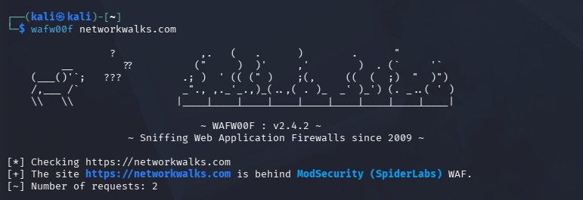
Figure 5: Wafw00f result identifying ModSecurity WAF

4.1.6 DNSRecon
Command Used:
dnsrecon -d networkwalks.com
Purpose:
DNSRecon was used to perform DNS enumeration of the target domain and identify publicly available DNS records such as SOA, NS, MX, A, TXT, and SRV records.
Observed Results:
- SOA record: ns6135.hostgator.com
- Name servers:
  - ns6135.hostgator.com
  - ns6136.hostgator.com
- MX record: mail.networkwalks.com → 192.232.216.135
- A record: networkwalks.com → 192.232.216.135
- SPF TXT record was identified.
- A Google site-verification TXT record was identified.
- Multiple _autodiscover._tcp.networkwalks.com SRV records were identified.
- The DNSSEC query returned no answer.
- Total records found: 8
Security Significance:
DNS enumeration provides information about the domain's infrastructure and associated services. DNS records such as name servers, mail servers, IP addresses, TXT records, and service records can help build a broader picture of the target's publicly exposed infrastructure during reconnaissance.
These findings represent information gathered during the footprinting exercise and do not by themselves confirm any security vulnerability.
Evidence:
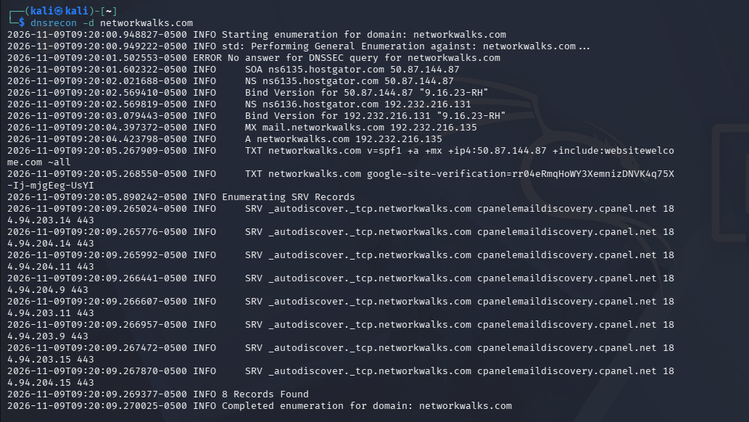
Figure 6: DNSRecon enumeration results for networkswalks.com

4.2 Network Scanning with Zenmap
Zenmap, the graphical interface for Nmap, was used to perform network discovery and identify active hosts on the local network. The purpose of this activity was to determine which devices were reachable and to observe basic host information.

4.2.1 Identifying the Local Network
The Windows ipconfig command was first used to identify the local IPv4 address, subnet mask, and default gateway.
Observed Network Details:
- IPv4 Address: 192.168.1.2
- Subnet Mask: 255.255.255.0
- Default Gateway: 192.168.1.1
- Network Range Scanned: 192.168.1.0/24
The /24 network range was selected based on the identified subnet mask.
Evidence:
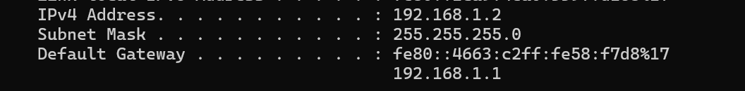
Figure 7: Local network configuration identified using ipconfig

4.2.2 Zenmap Ping Scan
A Ping Scan was performed in Zenmap against the network range 192.168.1.0/24 to identify active hosts.
Scan Type: Ping Scan
Target Network: 192.168.1.0/24
Observed Live Hosts:
- 192.168.1.1
- 192.168.1.2
- 192.168.1.4
- 192.168.1.5
A total of 4 active hosts were identified during the scan.
Evidence:
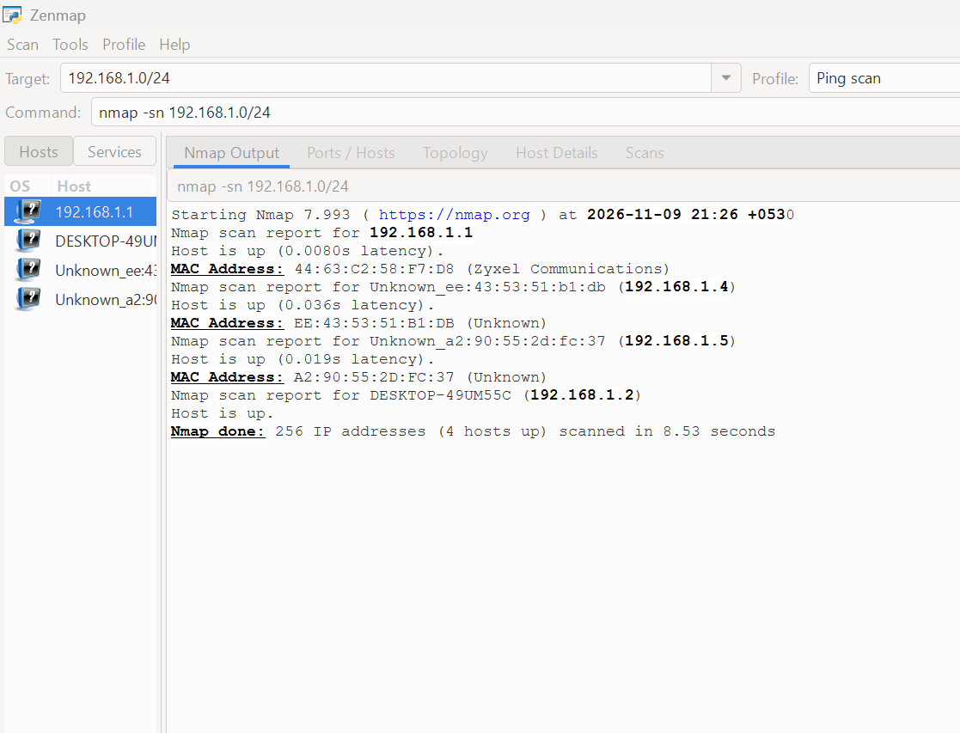
Figure 8: Zenmap Ping Scan showing active hosts

4.2.3 Host Details
The host 192.168.1.1 was selected in Zenmap to examine the available host information.
Observed Details:
- Host State: Up
- IPv4 Address: 192.168.1.1
- MAC Address: 44:63:C2:58:F7:D8
- Open Ports: 0
The result showed that the host was reachable, while no open ports were reported by this Ping Scan.
Evidence:
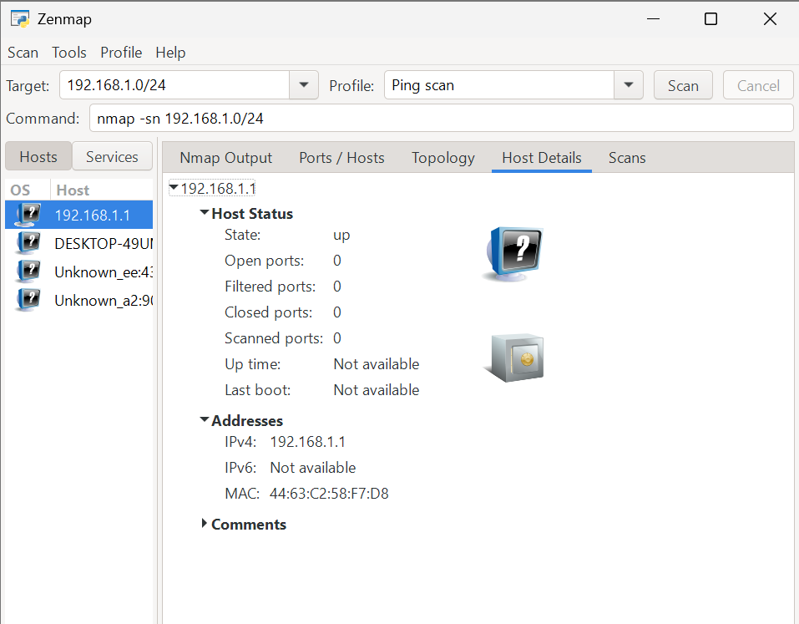
Figure 9: Host details for 192.168.1.1 in Zenmap

4.2.4 Network Topology
Zenmap's topology view was used to visualize the hosts discovered during the scan. The topology displayed the four identified hosts within the scanned network.
Observed Hosts:
- 192.168.1.1
- 192.168.1.2
- 192.168.1.4
- 192.168.1.5
The topology provides a visual representation of the discovered devices and can assist in understanding the basic structure of the local network.
Evidence:
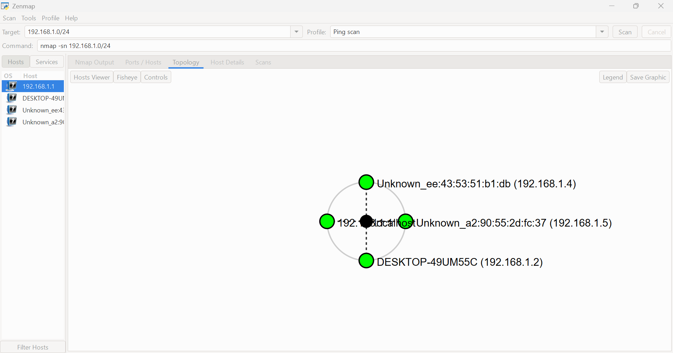
Figure 10: Zenmap network topology showing discovered hosts

5. Risk Analysis / Impact
The footprinting and network scanning activities provided information about the publicly accessible web infrastructure and the local network environment. The findings below represent observations obtained during the authorized practical exercises. They should not be considered confirmed vulnerabilities because no exploitation or vulnerability validation was performed.

Finding / Observation | Potential Security Impact | Risk
Domain registration and registrar information identified through WHOIS | Public domain information can assist reconnaissance and infrastructure profiling. | Low
Web technologies such as Apache, WordPress, WordPress Download Manager, jQuery and Bootstrap identified through WhatWeb | Technology and version information can help an attacker identify the technologies in use and research potential weaknesses. | Medium
Public IP address 192.232.216.135 identified through DNS and reconnaissance | The IP address provides information about the infrastructure associated with the domain and can be used for further authorized enumeration. | Low
HTTP response headers and WordPress-related information identified using Curl | Response headers may reveal server, application and configuration details useful during reconnaissance. | Low
ModSecurity WAF identified using Wafw00f | The presence of a WAF reveals a security control protecting the web application. No bypass testing was performed. | Informational
DNS records including NS, MX, A, TXT and SRV records identified through DNSRecon | DNS information can reveal infrastructure, mail services and other publicly available configuration details. | Low
Four live hosts identified in the 192.168.1.0/24 network using Zenmap | Discovery of active devices provides information about the network environment and may support further authorized enumeration. | Low
Host 192.168.1.1 identified as up with MAC address information | Host identification provides additional information about a device on the local network. | Informational

Overall Impact
The exercises demonstrated how publicly available information and basic network discovery can be combined to build an initial profile of a target environment. Information such as domain records, technologies, server details, IP addresses and active hosts can be useful during the reconnaissance phase of a penetration test.
The observations collected during this exercise should be reviewed and minimized where appropriate to reduce unnecessary information exposure. However, no exploitation, vulnerability confirmation, or unauthorized access was performed as part of these activities.

6. Recommendations
Based on the observations obtained during the footprinting and network scanning activities, the following recommendations are suggested:
- Minimize unnecessary information exposure
Review publicly available domain, DNS, server and application information and ensure that only information required for normal business operations is exposed.
- Keep web technologies updated
Regularly update WordPress, WordPress plugins, JavaScript libraries and other web technologies to their supported versions and apply security patches promptly.
- Review HTTP response headers
Periodically review HTTP response headers and remove unnecessary information that could reveal server or application details.
- Review DNS records
Regularly audit DNS records, including A, MX, TXT, NS and SRV records, and remove outdated or unnecessary records.
- Maintain and monitor the Web Application Firewall
Continue maintaining the identified ModSecurity WAF and regularly review its configuration, rules and logs to ensure that it provides appropriate protection.
- Perform regular authorized network discovery
Periodically scan internal networks to identify active devices and maintain an updated inventory of authorized hosts.
- Investigate unknown devices
Any unexpected or unauthorized devices identified during network discovery should be investigated and appropriate access controls should be applied.
- Conduct periodic security assessments
Regular authorized security assessments should be performed to identify configuration weaknesses and potential vulnerabilities before they can be exploited.
- Document network infrastructure
Maintain accurate documentation of network ranges, devices, services and infrastructure so that unexpected changes can be identified quickly.

7. Conclusion
The Week 2 practical activities provided hands-on experience with the footprinting, reconnaissance and network scanning phases of penetration testing.
During the footprinting phase, multiple Kali Linux tools were used to gather information about networkwalks.com. WHOIS provided domain registration information, WhatWeb identified web technologies, Nslookup resolved the domain to its IP address, Curl provided HTTP response header information, Wafw00f identified the presence of ModSecurity, and DNSRecon identified publicly available DNS records.
During the network scanning phase, Zenmap was used to scan the 192.168.1.0/24 network and identify active hosts. Four live hosts were discovered, and additional information was examined for the host 192.168.1.1. A network topology view was also generated to visualize the discovered hosts.
Overall, the exercises demonstrated how reconnaissance and network discovery can be used to build an initial understanding of a target environment. The activities were limited to information gathering and host discovery, and no exploitation or vulnerability validation was performed.

8. Evidences Collected
The following screenshots were collected during the Week 2 practical activities and are included as supporting evidence for the observations documented in this report.

8.1 Footprinting & Reconnaissance Evidence
- 01-whois.jpg — WHOIS domain information for networkwalks.com
- 02-whatweb.jpg — Web technology identification using WhatWeb
- 03-nslookup.jpg — DNS resolution using Nslookup
- 04-curl.jpg — HTTP response headers obtained using Curl
- 05-wafw00f.jpg — WAF identification using Wafw00f
- 06-dnsrecon.jpg — DNS enumeration using DNSRecon

8.2 Network Scanning Evidence
- 07-ipconfig.jpg — Local network configuration obtained using ipconfig
- 08-zenmap-ping-scan.jpg — Zenmap Ping Scan showing discovered hosts
- 09-host-192.168.1.1.jpg — Host details for 192.168.1.1
- 10-zenmap-topology.jpg — Zenmap network topology showing discovered hosts
All evidence was collected during the authorized practical exercises and corresponds to the activities and observations described in this report.

